**WELCOME to the**

**2014 Western Canadian Orienteering Championships**

August 8th Sprint event at the Valleyview Silt Cliffs Map, Kamloops

August 9th and 10th Middle and Long events at the Sabiston Creek Map, Savona

August 9th is Banquet Night in downtown Savona

Organizing Club: Sage O Club of Kamloops, with many thanks to

* Foothills Wanderers,
* Edmonton Overlanders,
* Greater Vancouver
* and Victoria O Clubs

We also wish to thank the City of Kamloops, Kamloops Cycling Performance Centre, Indian Gardens Ranch, Ministry of Forests Lands and Resource Operations; Coopers Foods; Piva Logging



[](http://www.orienteeringbc.ca/) 

**2014 Western Canadian Orienteering Championships**

**Please bring the signed waiver with you to the event.**

**WAIVER OF RESPONSIBILITY**

IF YOU DO NOT FULLY ACCEPT THE FOLLOWING CONDITIONS AND DO NOT SIGN THIS WAIVER, YOU WILL NOT BE PERMITTED TO PARTICIPATE IN THIS EVENT.

I, the undersigned, know that Orienteering, as an outdoor action sport, carriers significant risk of personal injury. I know that there are natural and man-made hazards, environmental conditions, and risks, which, in combination with my action, can cause me serious, or possibly even fatal, injury. I agree that I, as a participant, must take an active role in understanding and accepting these risks, conditions, and hazards. I also agree that I, and not the organizers and officials of this event, Sage Orienteering Club of Kamloops, the land owners or managers, or any sponsors, am responsible for my safety while I participate in this event.

Name (please print) ________________________________________________________

Signature _____________________________________________________________

Date ____________________________

Parent or guardian must sign if entrant is under 18 ____________________________________________________Date ____________________________

Welcome to the Valleyview Silt Cliffs Map and the WCOC Sprint event

Getting to the event

The event centre is at the Valleyview Arena on the east side of the city of Kamloops.

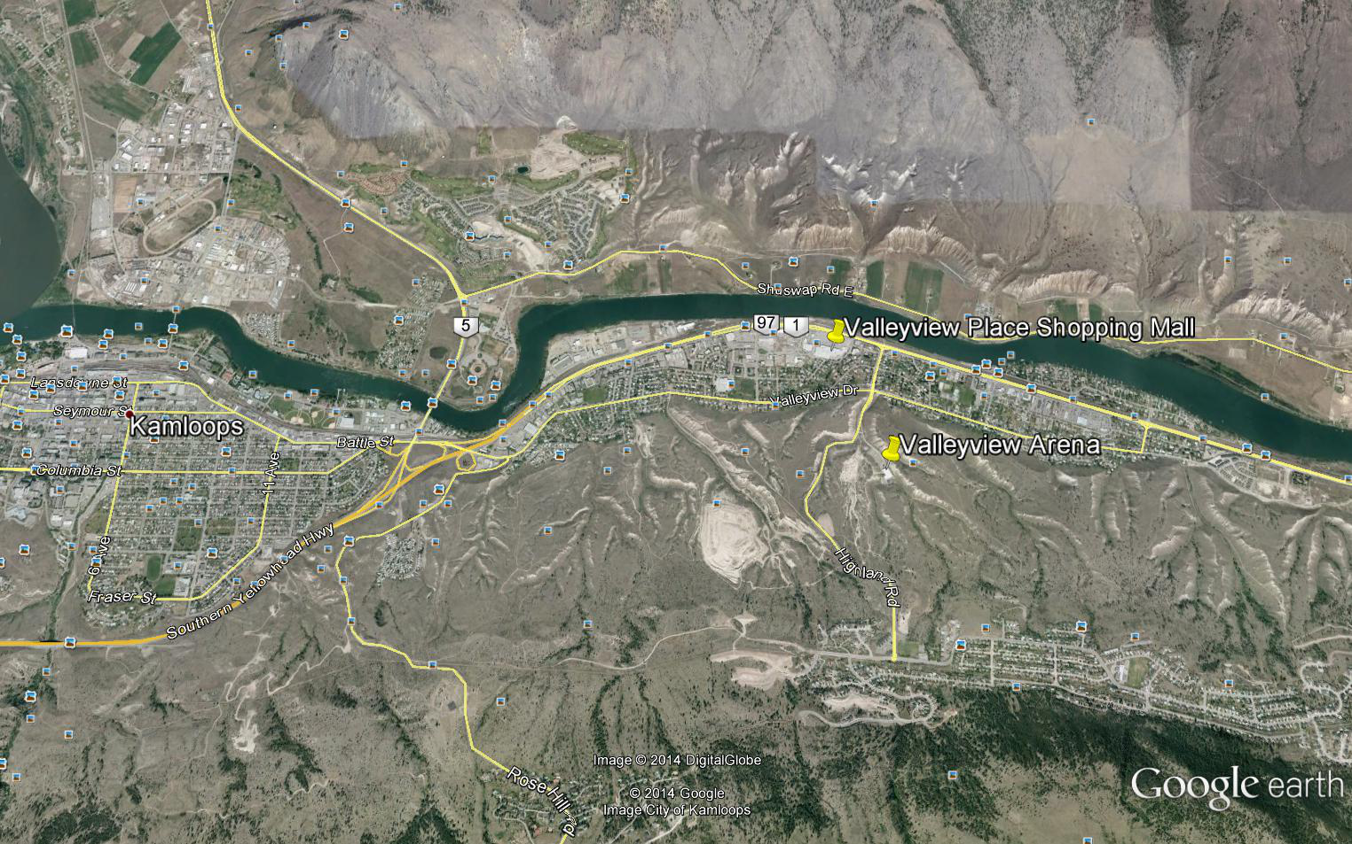

Turn off the Trans-Canada Highway at Highland Road. Drive one block to 4-way stop at Valleyview Drive. Drive straight and take next left to the Arena.

There is a grocery store and drug store in the Valleyview Place Shopping Mall.

**MAP INFORMATION**  
  
ISSOM  
Scale is 1:4,000   
Contours: 2.5m  
Size: 8.5" X 11",   
Mappers: Alan Vyse and Brian May 2014; Cartography by [Bryan](http://www.remmaps.it/index_en.htm) Chubb 2014  
Arena Elevation: 380m

**OWNERSHIP**

City of Kamloops Nature Park and Bike Ranch. We thank the City and the Kamloops High Performance Cycling Centre for permission to use the park and the Bike Ranch

**OFFICIALS**

* Meet Directors: Jacquie Bonn and Abbi May, Sage
* Sprint Course planner: Brian May, Sage
* Controller: Murray Foubister, Sage
* Start Chief: Karen Lachance, GVOC
* Finish Chief: Barry McCashin, Edmonton Overlanders  
    
  **MAP SNIPPETS**

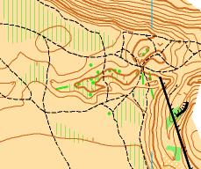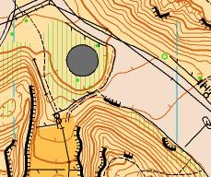

**MAP DETAILS**

The area was first mapped in 1995 at 1:15000 by Martin Pardoe and his map has been used for major events in the past. Sage O Club uses the map for introductory O events each spring.

The map area is within the City of Kamloops and the land is part of the City’s Parks system. The western side of the map is part of the Kamloops Bike Ranch which is operated by the Performance Cycling Centre in cooperation with the City of Kamloops. The “Ranch” is known throughout Western Canada as the “place to go” for bike riders who enjoy jumps. The east boundary of the map is private land and is marked by an un-crossable fence. On the western edge there is a major city road. North and South boundaries are steep grassy slopes.

About ten thousand years ago the map area lay beneath a large lake that was created by ice lobes blocking the North and South Thompson valleys in the vicinity of Kamloops. The ice dams collapsed and the water drained westward in a catastrophic event. Rapidly flowing water carved deep gullies in the former lake bed leaving the land much as you see it today. The gullies and cliffs have remained quite stable in the dry Kamloops climate. Building has not been permitted because of the risk of foundations being weakened as a result of water action.

The map is almost entirely open grassland, mapped as rough open. There are patches mapped as open land which is generally packed dirt and occurs in areas where bike trails and jumps have been built. Prominent trees and bushes have been mapped but small patches of trees have been mapped as rough open land with scattered trees. There are a few small areas of white forest. Some portions of the grassland are mapped as slow running because of knee-high to chest-high sagebrush.

Kamloops was heavily hit by the mountain pine beetle epidemic in the years between 2005 and 2007 when almost all large ponderosa pine trees were killed. There are many fallen trees on the map and individual stems have been mapped as solid green lines showing the approximate length and alignment of the fallen tree (they are visible on the aerial imagery). Patches of dead trees are marked as slow running.

Many un-crossable cliffs are mapped along the edges of the gullies. The cliffs are silt, not rock, and look like very steep earth banks. There are also many earth banks mapped as crossable.

Man-made features are common throughout the map. The main trail network has been created by bike riders and walkers, but bike riders have created many new trails in the western half of the map. There are a few vehicle trails. Within the western part of the map there are many bike jumps carved into the silt. Some are very large (>5m). They are shown by contour lines and form lines, and by knoll, bank, and wall symbols. There are numerous prominent manmade features including wooden ramps for jumps, signs and small buildings. There is one large building and parking lot – the Valleyview Ice Arena – which will be used as the Event Centre.

**SCHEDULE**

Registration desk at the Valleyview Arena will open at 8am

Start times begin at 10 am.

Maximum time allowed is 60 mins on all courses

Courses close at Noon. Bike traffic will begin after this time … so don’t be late!

**ARENA**

Arena announcer: none  
Vendors: The O-Store should be able to set up at the arena. No other vendors.  
Food: Please bring your own food

Water: Available in the arena; water will not be available on courses.   
Toilets: in the arena  
Distance to Start from arena: 100m.  
  
**START**

There will be a remote start for all courses. YOU MUST FOLLOW THE MARKED ROUTE TO THE START TRIANGLE.

**FINISH**

*ALL COMPETITORS MUST REPORT TO THE FINISH*

**SPECTATOR LEGS**

All competitors have a 300m run through the arena in the Middle. Runners on Courses 8, 9 and 10 have a spectator leg through the arena in the Long. Water will be available on these legs.

**MODEL MAP**

A model map will be available at Registration for the sprint at the Canadian Champs (see Murray Foubister) in the Valleyview Arena or it can be downloaded from the WCOC website.

**PARKING**

Use Arena Parking lot.

**HAZARDS**

**Hot weather**

Hot weather is a normal summer hazard in the BC interior and this summer is no exception. No Water will be provided on the sprint courses. Competitors should take their own precautions. **Make sure you are well hydrated** **before your start time** and take water with you if you expect to be out on the course for a lengthy period of time.

**Bikes**

The map covers part of the Kamloops bike Ranch. The Bike Ranch will be closed for the morning of the Sprint event with the cooperation of the City and the Bike Ranch operators but it is possible that bikers will try to use the area. Stay alert!

**Bike jumps**

Please do not climb on the bike jumps. Controls will be placed in the vicinity of jumps but there should be no reason to go on the jumps.

**Course class table**

|  |  |  |  |  |  |  |
| --- | --- | --- | --- | --- | --- | --- |
| **WCOC Event** | **Course** | **Class** | **distance km.** | **climb m.** | **# of controls** | **time limit on course** |
| Sprint | 1 | Beg, M12, M14, W12, W14 | 1.4 | 50 | 15 | 1 hour |
|  | 2 | Int., M75, M80, M85+, M80, W55, W65, W75, W80, W85+ | 1.2 | 55 | 17 | 1 hour |
|  | 3 | Adv., M55, M65, W45 | 1.9 | 90 | 19 | 1 hour |
|  | 4 | Exp., M16, W16, W20, W21, W35 | 2.1 | 95 | 22 | 1 hour |
|  | 5 | M20, M21, M35, M45 | 2.4 | 120 | 22 | 1 hour |

Welcome to the Sabiston Creek Map and the WCOC Middle and Long events

Getting to the events

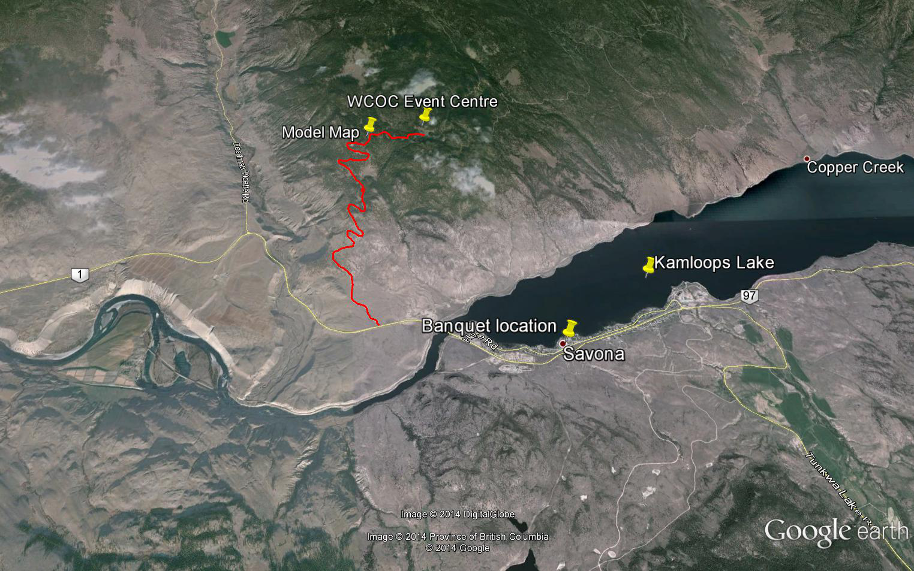

The event centre is 9 km north of the junction of Sabiston Creek Road and Highway 1 a few hundred meters west of bridge that crosses the Thompson River at the west end of Kamloops Lake and about 2k from the west access to Savona and the access to Steelhead Provincial Park. The road is signposted to Tranquille, Red Lake, Criss Creek and Copper Creek. Turn North on the road. It is winding, steep and rough in places, and is likely to be dusty especially on the hairpin bends. **The road is suitable for highway vehicles.** Kilometer markers are attached to trees at 7km and beyond. The model map start is at 7.5 km.

Savona is the nearest community, east of the bridge and the Sabiston Creek road. The hamlet has a school, a gas station and small store, a licensed diner (Millers Crossing) beside the gas station, a pub, a community hall and a swimming beach and picnic area beside the hall. There is a “boil water” advisory in Savona at the time of writing and you can only buy bottled water or beer in the diner. Such a shame! Savona is about 40 minutes from downtown Kamloops.

**MAP INFORMATION**  
  
ISOM  
Scale is 1:10,000 for all Middle event classes and for all Long event classes with the exception of M21, W21, M17-20 and M35 who will use 1:15,000  
Contours: 5m  
Size: 8.5" X 14"  
Mappers: [Bryan](http://www.remmaps.it/index_en.htm) Chubb 2010-2014; Alan Vyse 2013-14  
Arena Elevation: 1050m

Safety bearing: use either North or South to the road that runs through the middle of the map from west to east



*We chose the Western Tanager as the symbol for the map because it lives on the map, it is western, and it is beautiful.*

**OWNERSHIP**

The south half of the map is crown land managed under lease by our good friends from Indian Gardens Ranch … the Haywood-Farmer family. We thank them for their cooperation. The northern half is crown land.

**OFFICIALS**

* Meet Directors: Jacquie Bonn and Abbie May, Sage
* Course planner: Alan Vyse, Sage
* Controller: Marion Owen, Foothills Wanderers
* Start Chief: Karen Lachance, Greater Vancouver OC
* Finish Chief: Barry McCashin, Edmonton Overlanders
* IOF Event Advisor: John Rance, GVOC
* Registration: Leigh Bailey, Victoria Orienteers

**MAP SNIPPETS**

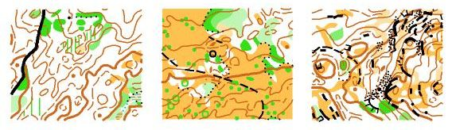

**MAP DESCRIPTION**

The map has an interesting mix of terrain …. or should we say terroir? If the map was to be compared to other BC maps in wine terms we might say it has the grassy flavours of Lac Du Bois and mineral hints of Six Mile Hill. The bouquet of tree needles is similar to McQueen Lake and with subtle overtones of Edith Hill fruit but without the excess of deadfall resin. It drinks well on first encounter but will cellar for many years. In other words this map is destined to be a Kamloops classic! For the orienteering connoisseur there are areas of detailed forested terrain, open grassland, rounded rocky hilltops and runnable open forest. There are lots of rock features, ponds, and thickets and a few watery features. Wet feet will be rare. The forest is open and runnable but footing is uneven in rocky areas. There are patches of unpleasant thick vegetation with reduced visibility however many of these patches were too small to map. In addition, the map was created over a period of 5 years and the course setting team noticed minor reductions in runnability that are not reflected on the map as a result of tree growth. For the beginning orienteer there are trails and rides and ponds to provide handrails. A main forest road bisects the map but traffic has been light and the road can be crossed with caution.

Large sections of the map were logged 20 years ago and this created open forest and good running on the map. A small section of the southwestern edge of the map was logged last winter and while open, footing is uneven because of woody debris and running is slow.

The ponds on the map will vary in water levels. Last winter’s snow levels were quite high so there is lots of water this summer (2014) and water levels are high. This may change with warm weather in July.

**MODEL MAP**

The model map is a very small portion of the overall map. The start is on the southwestern edge of the main map at 7.5km on the Sabiston Creek Road. It displays the combination of features you will encounter during the two days of competition. Maps will be distributed at Registration for the COCs on Friday August 1st. Copies will also be available at Registration for the WCOC Sprint in the Valleyview Arena. There will be a signs and a start control at the junction of the main road and the Smith Camp Forest Road. Control locations will be marked with standard flags and flagging showing the location letter. THE MAN MADE FEATURE IS A LARGE WOOD DEBRIS PILE. It is marked on the map as dense vegetation in the centre and is surrounded by a thick black line. There will be a toilet at the road junction by 2pm and more at the event centre at Km9.

Fewer controls are marked on the 1:15000 map because the area is so small.

Parking is along the main road and the first 50m of the side road. PARK WITH CARE!

**SCHEDULE**

Registration desk at the Sabiston arena will open at 8am

Start times for both WCOC events on the Sabiston map begin at 9am.

Maximum time allowed is 120 mins for all Middle courses and 180 minutes for all Long courses.

Courses close at 12.30pm for the Middle and 2pm for the Long

**ARENA**   
  
Arena announcer: none  
Vendors: The O-Store should be able to set up at the arena. No other vendors.  
Food: Please bring your own food and enjoy a picnic after your run

Water: Please bring lots of water but water will be available on courses.   
Toilets: port-a-potties close to the arena  
Distance to Middle Start from arena: 1km on road. Allow 15 minutes.  
Distance to Long Start from arena: 500m on good trail allow 10 minutes.

See arena maps below  
  
**START**

There will be a remote start for all courses. YOU MUST FOLLOW THE MARKED ROUTE TO THE START TRIANGLE.

**FINISH**

*ALL COMPETITORS MUST REPORT TO THE FINISH*

**PARKING**

Parking is available along the main road between Km 8 and the arena at Km 9. There is no parking beyond the arena unless otherwise directed. Please park on one side of the road only as directed.

**HAZARDS**

**Hot weather**

Hot weather is a normal summer hazard in the BC interior and this summer is no exception. Water will be provided on both the Middle and Long courses but competitors should take their own precautions. **Make sure you are well hydrated** **before your start time** and take water with you if you expect to be out on the course for a lengthy period of time. In the long event there will be water on the main road that traverses the site and at a few control sites. If the weather is very hot, extra water will be provided on the courses (See the hot weather tips below).

**Animals**

The mappers encountered deer and bears on the map. A young bear was seen on the east end of the map on July 31st. Cows graze the area but are likely to be much further north at the time of the event. Horses also graze the area. Rattlesnakes are present but none were seen or heard during preparations for the meet. However, a rattlesnake was seen on the West side of the map in late June. Big horn sheep were seen on the road up to the map. Mosquitos are present but not in large numbers.

**Vegetation**

Wildflowers were abundant in May and June but sadly will be brown and dry by August. Nasty vegetation consists of thickets of willow or Douglas-fir. There is no Devil’s club or salal within 50 km of the map but there are a few prickly pear cacti on the southern rocky slopes.

**Fire**

The Forest Fire Hazard at the time of writing is High and a campfire ban is in place. We have to take great care with any possible sources of ignition and for this reason we will not allow any camping on site. We will have an evacuation plan for the event and more information will be distributed as we get closer to the event. Evacuation maps will be available. If we get more hot dry weather in the next three weeks, and big fires in the local area, it is possible that a Forest Closure might be announced. If this happens we may be forced to cancel the Middle and Long events. This is unlikely.  
  
**Logging traffic**

Loggers may be using the main road to access a site some distance away from the event. Logging trucks could be using the road at night during the week before the event. We don’t expect any impact on the event other than extra dust, but we have learned to expect the unexpected. Once again, take care on the road.

**BANQUET**

The Saturday evening meal will be held in the Savona Community Hall close to the swimming beach and picnic area, and close to the Pub. Savona is about 4 km long, spread out along the railway and highway. There are two Highway 1 access points. The community hall is about 1km from the western entrance, which is also the entrance to Steelhead Provincial Park and camping area.

**HEAT ILLNESS PREVENTION CHECKLIST FOR ORIENTEERS**

Heat illness (heat exhaustion, heat stroke) can strike with little warning. Susceptibility to heat illness varies according to the individual.  
  
**Risk Factors:**

* History of heat illness
* History of chronic illness (even if controlled)
* Current illness (e.g. flu, sunburn)
* Heat stress index (depends on temperature and humidity)
* Fatigue
* Improper hydration (too little, wrong time)
* Poor fitness
* Young age (children have less developed defence mechanisms)
* Multi-day exposure to heat stress.
* Diet supplements such as aphedria and some antihistamines.
* A “finish at all costs” attitude.

Orienteers should take the actions necessary to keep the heat stress level with within their tolerance capabilities.  
  
**Risk Reducers:**

* Hydrate **numerous** days before the event (starting the night before is inadequate).
* Consume proper foods by type and amount
* Get proper rest
* Replenish your fluids regularly from the water stops on course
* Acclimatize yourself to the heat/humidity at least a week before the event
* Befit upon arrival at the event.
* Wear a head covering
* Carry and use your own fluid replenishment supply.
* Modify your pace to suit the environmental and personal conditions. Don't start if conditions are too hazardous for **you.**
* Rehydrate immediately after the event, **that night, and the next day.**
* Replenish your electrolytes after the event by drinking sport drinks and eating fruits and vegetables.
* Be aware that your susceptibility to heat illness increases as the days of exposure continue.
* On the course be conscious of your physical and mental condition. For example, if you feel `punchy' or dizzy when raising your head:
* Stop immediately
* Get under shade
* Drink

**WCOC 2014 Course/class table**

|  |  |  |  |  |  |  |  |  |
| --- | --- | --- | --- | --- | --- | --- | --- | --- |
| **WCOC Event** | **Course** | **Class** | **distance km.** | | **climb m.** | **# of controls** | **time limit on course** | **size of control description sheet**  **mm.** |
|  |  |  |  | |  |  |  |  |
| **Middle** | 1 | Beg, M12, W12 | | 2.6 | 45 | 15 | 2 hours | 40 x 125 |
|  | 2 | M14, W14 | | 2.7 | 60 | 12 | 2 hours | 40 x 110 |
|  | 3 | Int, M16, W16 | | 2.9 | 90 | 15 | 2 hours | 40 x 120 |
|  | 4 | M85+, M80, W75, W80, W85+ | | 2.1 | 60 | 11 | 2 hours | 56 x 150 |
|  | 5 | Adv, M75, W55, W65 | | 2.5 | 100 | 14 | 2 hours | 40 x 115 |
|  | 6 | M65, W45 | | 2.7 | 105 | 15 | 2 hours | 40 x 120 |
|  | 7 | Exp, M45, M55 | | 3.0 | 110 | 16 | 2 hours | 40 x 125 |
|  | 8 | W20, W35 | | 3.3 | 120 | 15 | 2 hours | 40 x 120 |
|  | 9 | M20, M35, W21E | | 4.3 | 140 | 21 | 2 hours | 40 x 151 |
|  | 10 | M21E | | 5.1 | 195 | 26 | 2 hours | 40 x 175 |
|  |  |  | |  |  |  |  |  |
| **Long** | 1 | Beg, M12, W12 | | 2.6 | 40 | 14 | 3 hours | 40 x 120 |
|  | 2 | M14, W14 | | 3.5 | 60 | 14 | 3 hours | 40 x 105 |
|  | 3 | Int, M16, W16 | | 3.9 | 115 | 17 | 3 hours | 40 x 125 |
|  | 4 | M85+, M80, W75, W80, W85+ | | 2.7 | 80 | 10 | 3 hours | 56 x 125 |
|  | 5 | Adv, M75, W55, W65 | | 3.8 | 125 | 10 | 3 hours | 40 x 100 |
|  | 6 | M65, W45 | | 4.6 | 180 | 11 | 3 hours | 40 x 95 |
|  | 7 | Exp, M45, M55 | | 5.8 | 210 | 14 | 3 hours | 40 x 110 |
|  | 8 | W20, W35 | | 5.4 | 180 | 13 | 3 hours | 40 x 105 |
|  | 9 | M20, M35, W21E | | 8.2 | 310 | 18 | 3 hours | 40 x 135 |
|  | 10 | M21E | | 12.4 | 455 | 22 | 3 hours | 40 x 155 |

Competitors in the M85+, W80 and W85+ will be given the option of competing on a slightly shorter Course 4 for the Long event on Sunday. In addition, the map will be printed at 1:7500. This is an option and all competitors in each class must agree to the change. Competitors will be approached by the organizers at the Canadian championships in Whistler to seek agreement. They can contact Alan Vyse, Marion Owen or John Rance for more details.

